# Experiment-2.1

## Student Name: Nabha Varshney UID: 20BCS4995

**Branch: CSE Section/Group: 20BCS-DM-704 (A)**

## Semester: 6th Date of Performance:05th Apr 2023 Subject Name: Competitive Coding II Subject Code: 20CSP- 351

**Aim** – To demonstrate the concept of Trees

## Objective-

* The objective is to build problem solving capability and to learn the basic concepts of data structures.
* The implementation of balanced binary tree which shows and brushes up the concept of Trees and can be solved through various approaches.
* The implementation of path sum problem in C++.

## Balanced Binary Tree

<https://leetcode.com/problems/balanced-binary-tree/>

**Code –**

class Solution {

  public boolean isBalanced(TreeNode root)

    {

      return height(root)!=-1;

    }

  public int height(TreeNode node){

    if(node==null)

      {

         return 0;

      }

    int leftHeight=height(node.left);

    if(leftHeight==-1)

        return -1;

    int rightHeight=height(node.right);

     if(rightHeight==-1)

        return -1;

     if(Math.abs(leftHeight-rightHeight)>1)

        return -1;

    return 1+Math.max(leftHeight,rightHeight);

}

}

## Output -

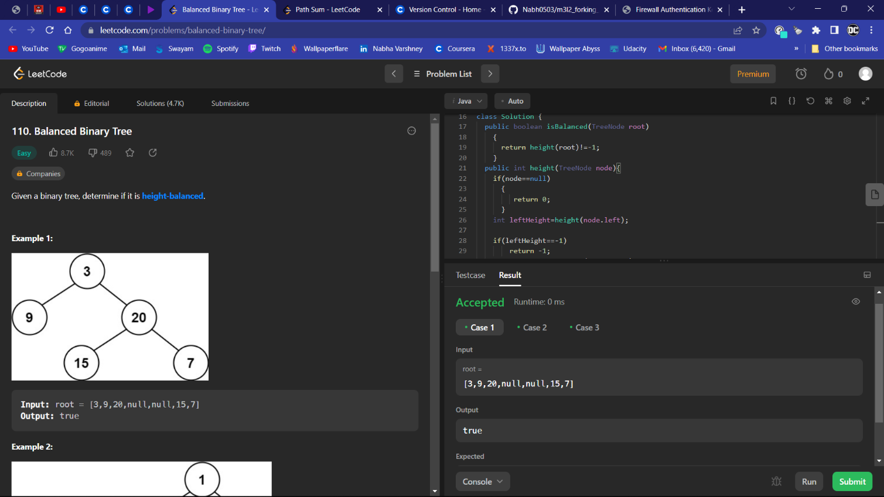

1. **Path Sum**

<https://leetcode.com/problems/path-sum/>

**Code -**

class Solution {

  public boolean hasPathSum(TreeNode root, int targetSum) {

     if (root == null)

      {

         return false;

      }

     if (root.val == targetSum && root.left == null && root.right == null)

      {

        return true;

      }

  return hasPathSum(root.left, targetSum - root.val) ||

         hasPathSum(root.right,targetSum - root.val);

}

}

## Output –